Interdisciplinary course of

**Design and Robotics**

5° edition, 2017

Professors:

Andrea Bonarini, DEIB department, Politecnico di Milano

Maximiliano Romero , DPAC department, Università IUAV, Venezia

Tutors:

Andrea Brivio, Yael Bendit,

Students:

Julián David Gallego, school of Engineering

Emanuele Luca Schiavon, school of Engineering

Angelo Falci, school of Engineering

Valentina Favaro, school of Design

Sohail Gambari, school of Engineering

# Index

**Index** **2**

**Abstract** **3**

**Description** **3**

**Research** **3**

State of the Art 3

Inspiration 4

Representation 5

**Development** **5**

Interaction 5

Shape 5

Mechanics 7

Electronics 10

Informatics 13

**Conclusion** **13**

**Bibliography** **14**

**Annex** **15**

Interaction 15

Shape 15

3D model? Technical drawings? 15

Mechanics 15

3D model? Technical drawings? 15

Electronics 15

Informatics 15

# 

# 

# Abstract

In this article you will find a complete description of the building process and the development of the entire project, from the first ideas up to the final result, through by all the problems and the solutions. The functional area of the robot is an attractive robot, to persuade people to enter in a mexican restaurant.

# Description

The main goal of this project was to develop a robot capable to attract the attention of the people, for commercial purpose. In particular, we build a robotic Cactus for a Mexican restaurant, setting up the electronic, developing the firmware, building the mechanics.

Later we had to design a choreography and a covering of the robot according to the type of restaurant that we want to promote, the Mexican Restaurant.

The secondary goals were to share our knowledge for each specific area, develop our group working ability and be able to respect the schedule and present a good product.

# Research

## State of the Art

We have started thinking about a shape for our robot. To do this we made a google research to find which way was the one easier that can create an understandable interaction, a good design and that can reflect our inspiration without trying to do a copy of reality. We’ve found the best way to do this is to use geometrical based simple figures: it’s easier to put all the electronic stuff inside it and to be clean and understandable, to create something that’s inspired by reality but non really the same.

From our research it has been observed also that is used a lot in the robot world to create a sort of character: it helps to make understandable the interaction and also to be attractive because it becomes immediately friendly to people who approach to it.

Since the concept has been established we’ve decided that a cylinder was perfect to represent our “cactus” inspiration. We’ve thought about all the senses to use to be nearer the people and, further the electronics area like the creation of sounds, we’ve thought to take advantage also of the design part: we have tried to give a particular texture for the touch so that it can create a link in our mind to the strange cactus surface.

To do this we’ve find on internet some different ways to create a silicon object. We wish to be able to create a silicon body with a mold or to print it on 3d and cover it with a little silicon layer. For this first step we’ve focused on the right shape and on the understanding of the relation between movement, mechanical parts, and shape. For this reason, we’ve used a rubber foam with a layer of silicon.

Research keywords: robot shape, robot material, robot character, silicon objects, robot expressions, robot movements, mold, 3d print, interaction interface etc.

## Inspiration

The ideas arrived thinking about what message we would have like to express: a funny robot, a friend easy to feel near you and to approach, a little enjoyable character. We’ve reasoned about what type of restaurant has this mood of joy and we’ve decided the Mexican restaurant was the perfect one with all its colors, music and warm atmosphere.

We didn’t want to create a human like figure so we decided to choose a Mexican element to create our personal character and we immediately thought about cactus plant.

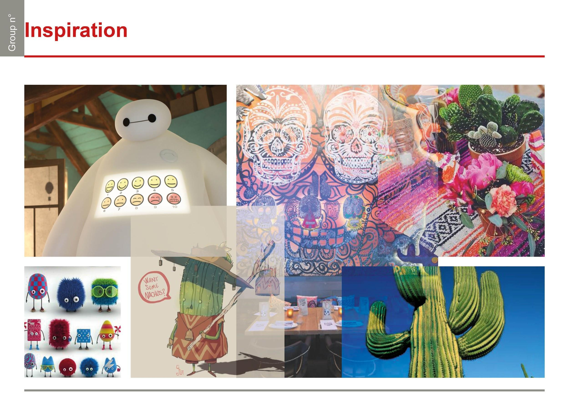

## Representation

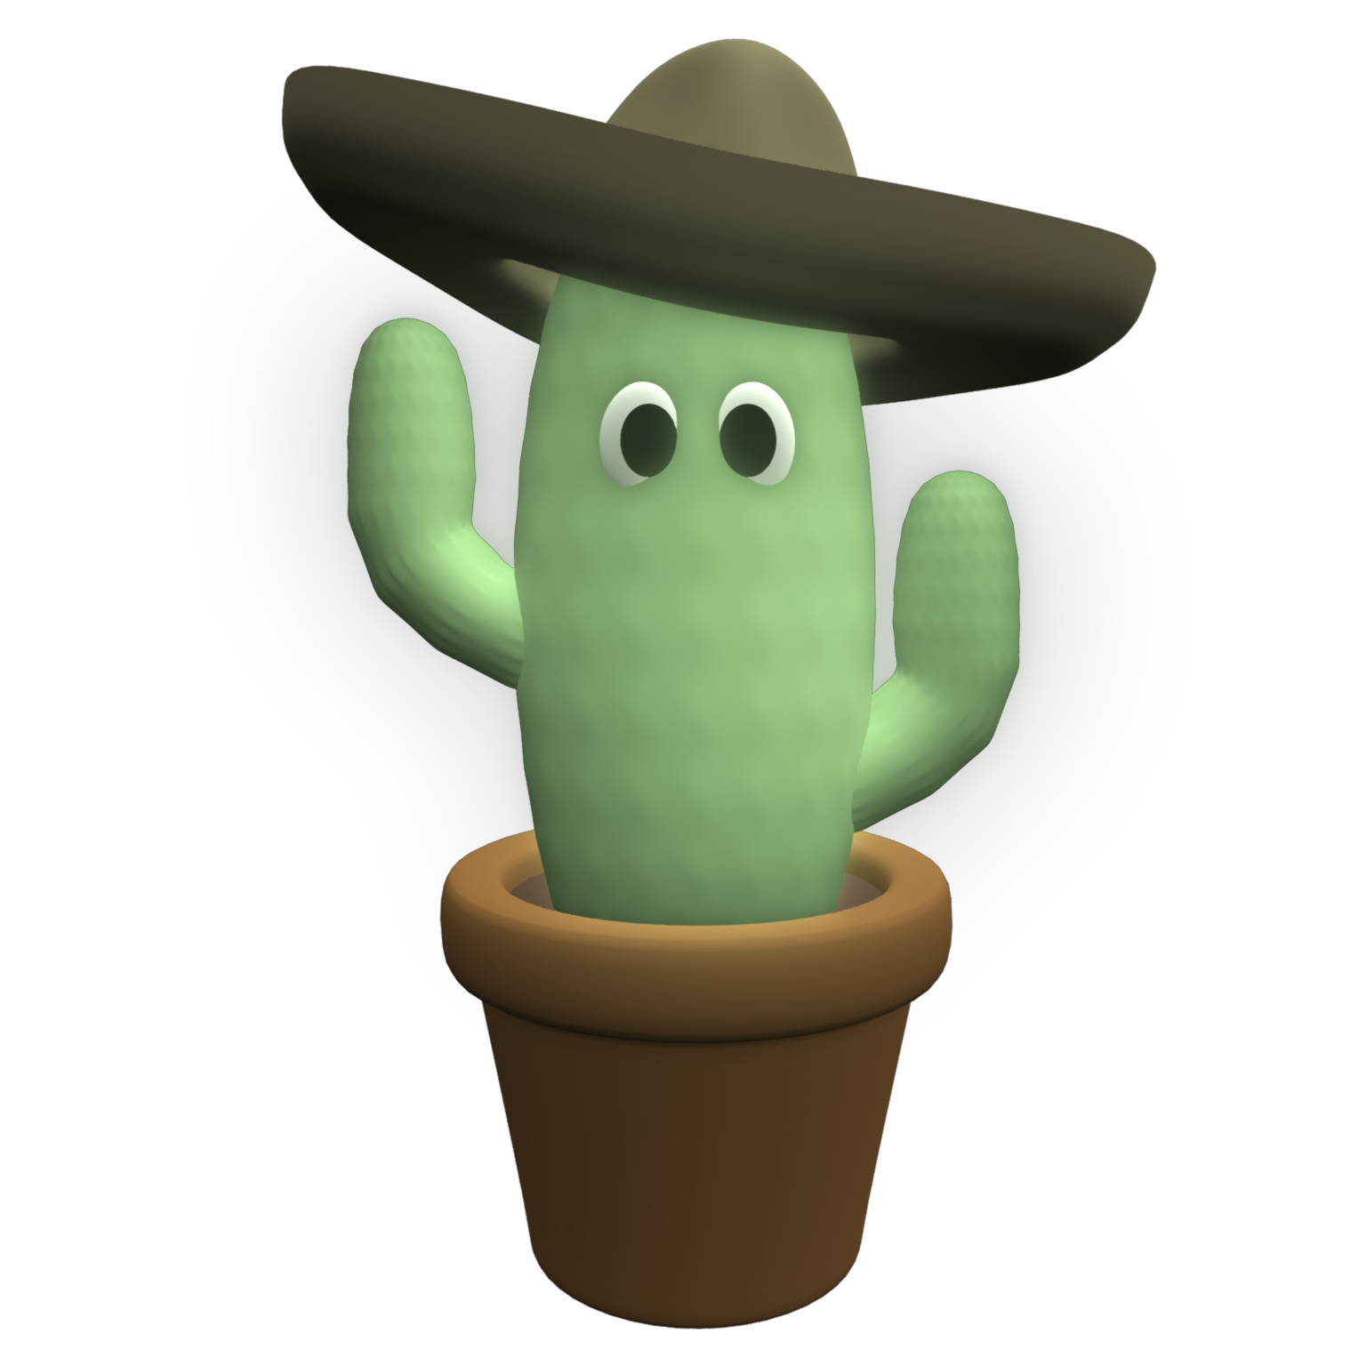

# Development

## Interaction

When there isn’t anyone in front of it Gonzalo enter in the “Cucaracha Mode”, is songs the Cucaracha and moves the arm with the flag with blue eyes.  
When someone is detected Gonzalo say “Hi” and offers Taco to the person with green eyes (the eyes return blue when Gonzalo finishes to say Hi).  
Now can happen 3 thing:

1. If the person go away Cucaracha mode starts again.
2. If the person doesn’t take Taco but stay in front of it Gonzalo says other sentences like “Prova i nostri burritos” or “Fidati Gonzalo, prova messicano”.
3. If the person try to take the Taco, Gonzalo move the arm away and laugh with an angry expression and red eyes. After a few seconds the arm is set up in the initial position.

While Gonzalo interact with the person its body follows the person in front of it.

Now we are going to present the flowchart of the interaction of the robot: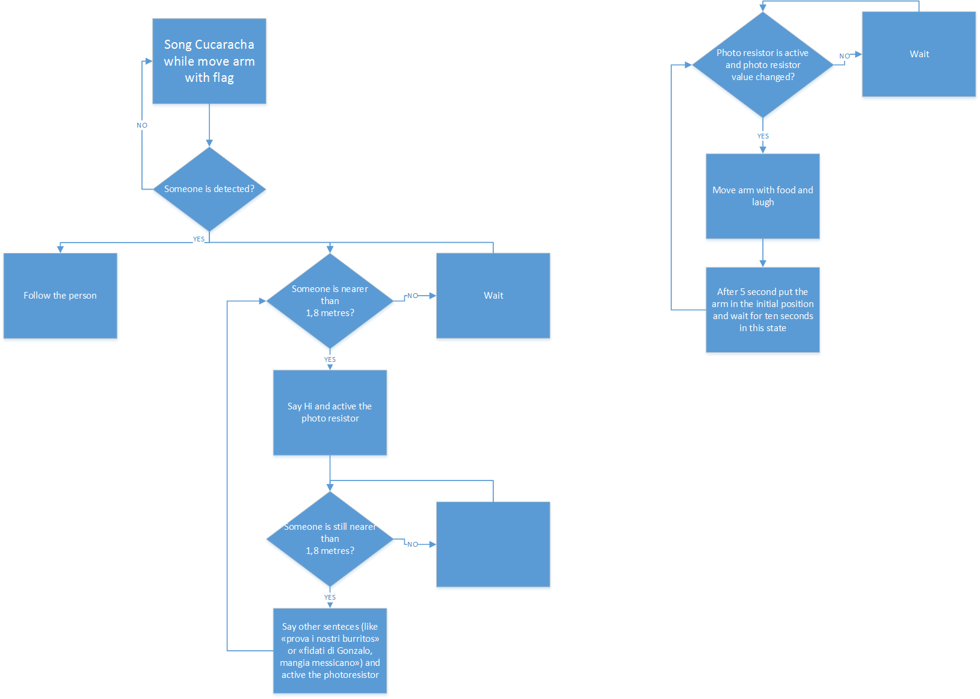

## Shape

## IMG-20170326-WA0052.png

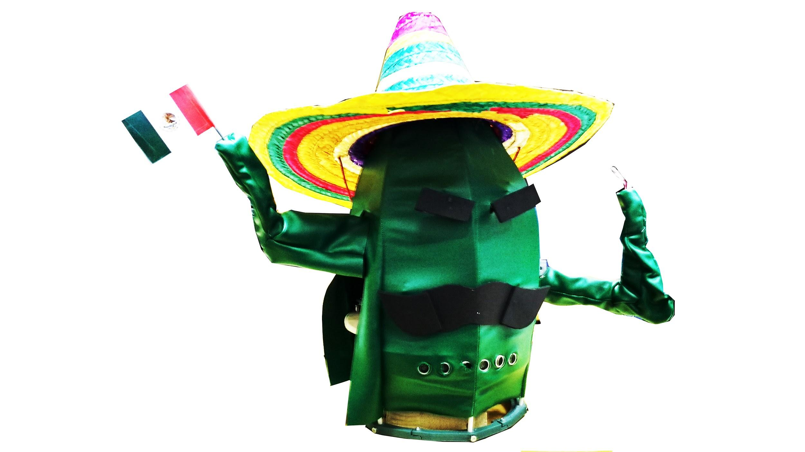



The shape of the robot is designed to look like a Cactus, made of a main cylindrical body becoming smaller on the top as real cactus does. On this main structure two branches are attached, having the typical L-shape of ones of the cactus. These act like they were the arms of the robot. Finally, a sombrero is placed on the top of the robot.

The mechanical skeleton is made of aluminium and wood, the external body is made of foam rubber: to give the perception of the cactus “skin” it has been painted with green fluo vynil and after that we have put a silicon layer on it; finally, we’ve done some shades with a green spray can for the first prototype, for the final product we did a tensile structure with a green textile to give the form of a captus, also using 3D printing for some pieces required unique for this robot: the part on the top used to connect and unite the bars needed for the structure and a circle for the base for the same reason. Also the arms are done similar to a tensile structure using iron wire trough every part to be easy to modify their form.

Sonars are all in a band and refined in the fabrics with transparent plastic obtained from a transparent tube.

Moustaches are made with soft rubber. Finally eyes are made using sylicon fabric to obtain more diffusion of the led light.

The robot has totally five degrees of freedom, driven by five servo motors. One controls the rotation of the main structure, two are used for the arms and the remaining two allow the movements of the eyebrows and of the moustache.

## Mechanics

The mechanical skeleton is composed by two disks of wood, the upper one is able to rotate with respect to the lower one thanks to an articulated quadrilateral, this type of link permits to focus all the weight on a ball gearing instead of charging the servo motor. This solution reduces the friction between the elements and therefore the power required from the motor is reduced too.

On the upper disk are mounted two vertical pieces of wood that form the structure on which are placed two elements of aluminium with a U profile, going horizontally in two different directions. On these elements, placed at different height, are mounted the two arms of the robot, made of aluminium. Although the arms have the same shape, they behave in different ways. In fact, the right arm performs a rotation of its last element on a plane perpendicular to the ground and passing through the two arms, while the left arm perform itself a rotation on a plane parallel to the ground.

Since the external part is light and soft the mechanisms for the eyebrows and for the mustaches can’t stand on it but it’s rigidly fixed to the main structure. Those mechanisms are equal and are composed by two pulleys, one is driven by a servo motor, while the other is driven by the first one thanks to a wire. In order to transmit the motion this mechanism doesn’t use the friction of the wire since it is fixed with a node. This solution has the con to don’t allow a complete rotation but, since it is not necessary, it has the pro to be more reliable and cheap.

The eyebrows and the mustaches moves thanks to four rotating elements made of steel, belonging to the mechanism and passing through the body, they so transmit the motion to the external elements on the face.

All the servo motors, except the two used for the face, use an articulated quadrilateral system to drive the different elements, this brings us all the advantages explained before.

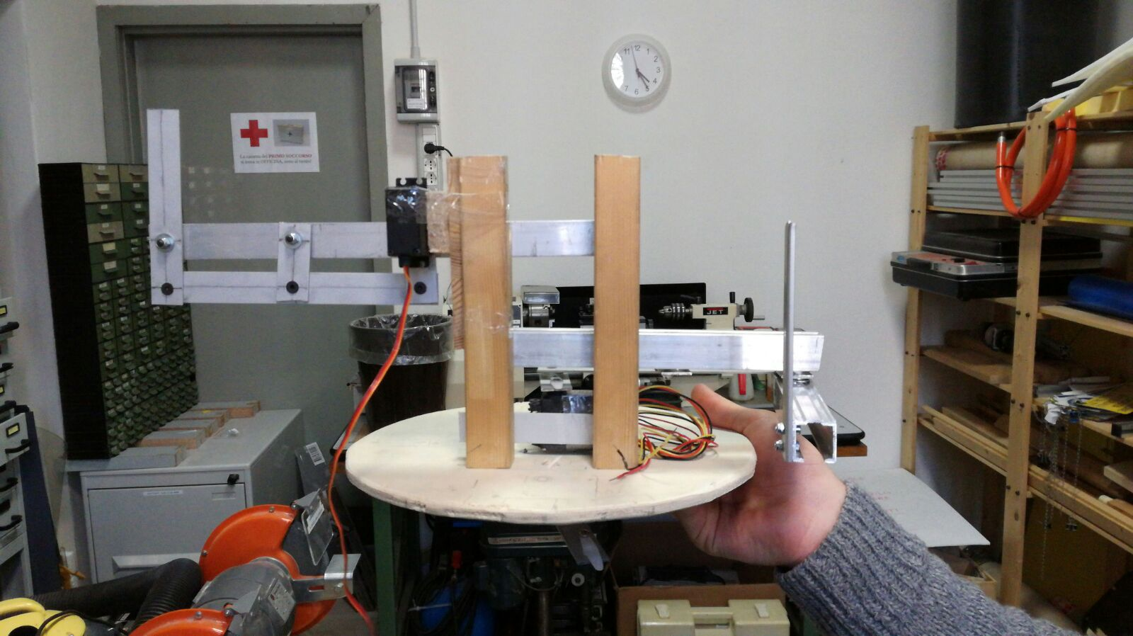

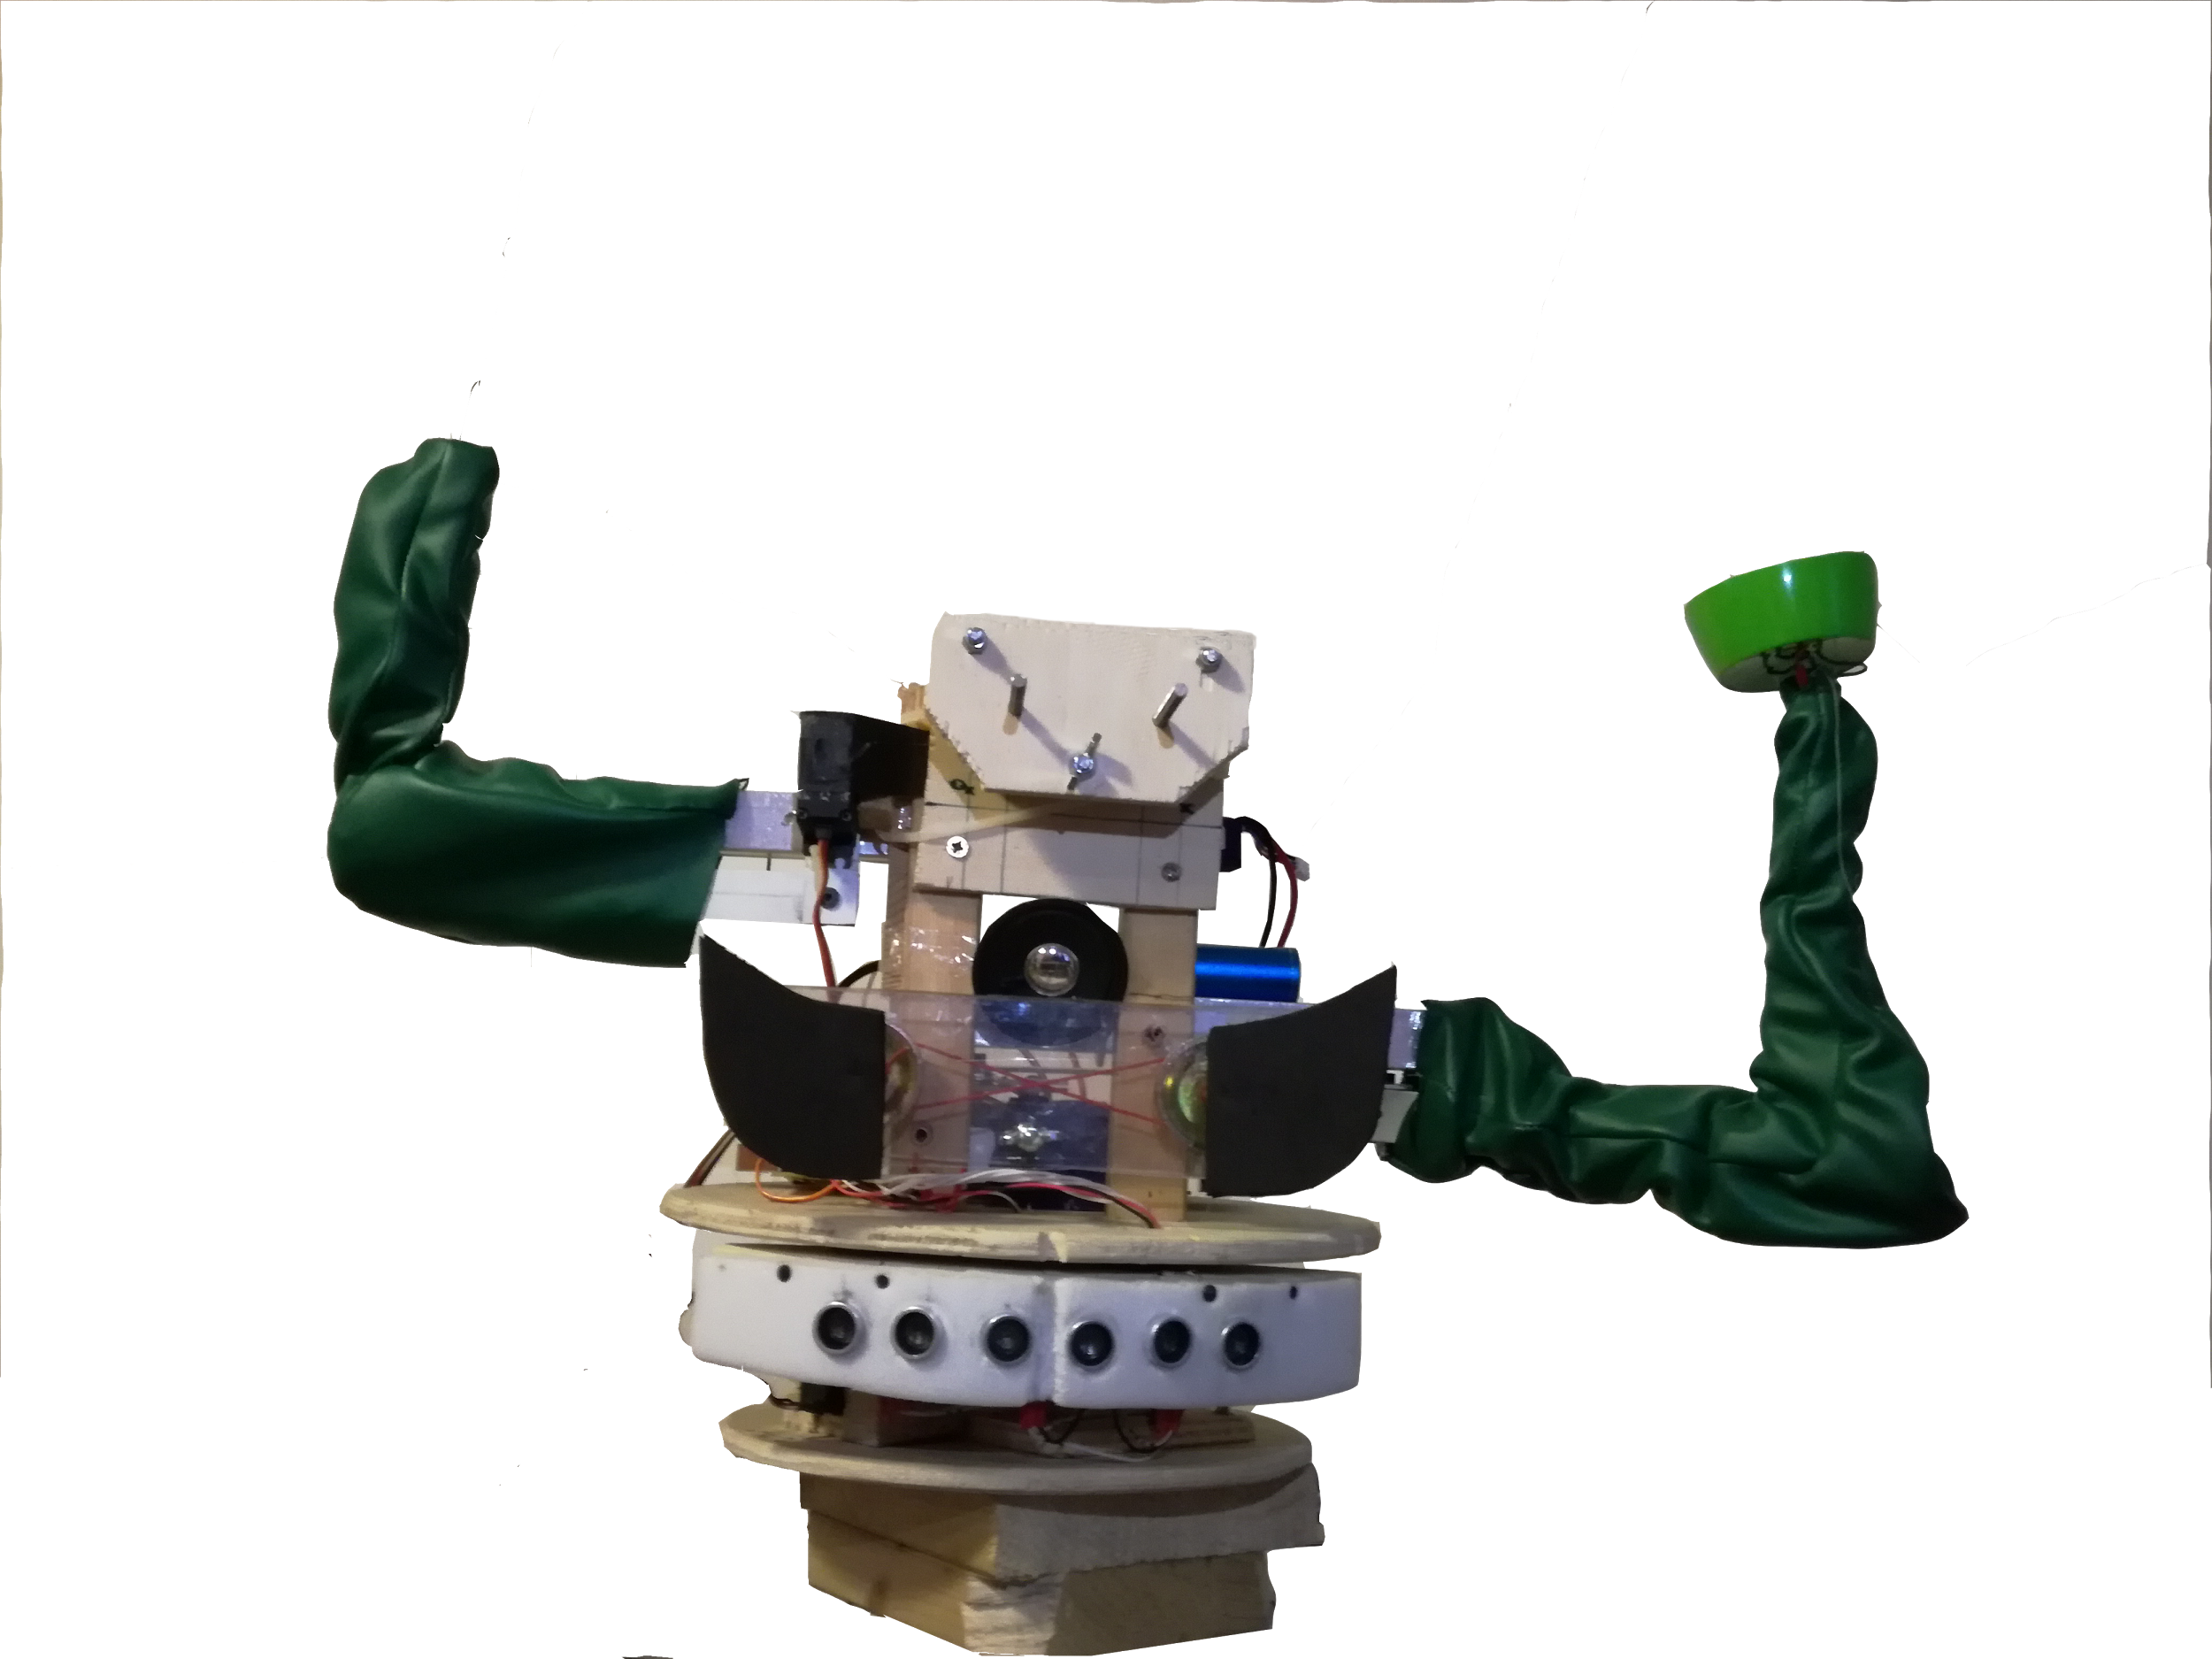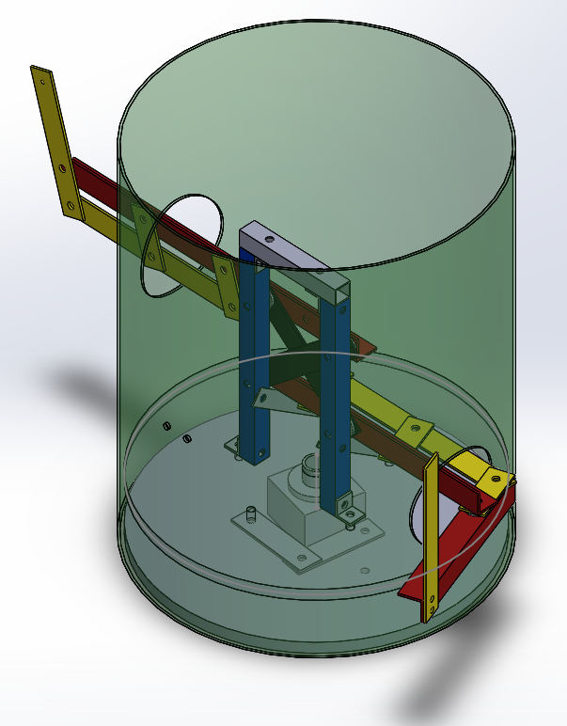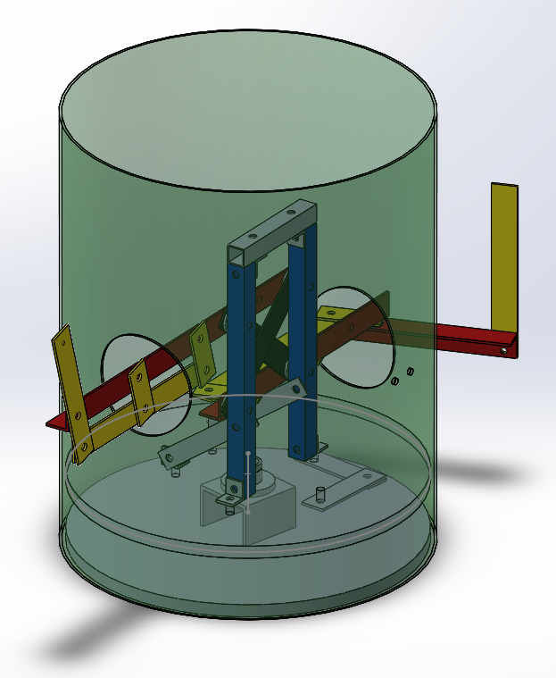

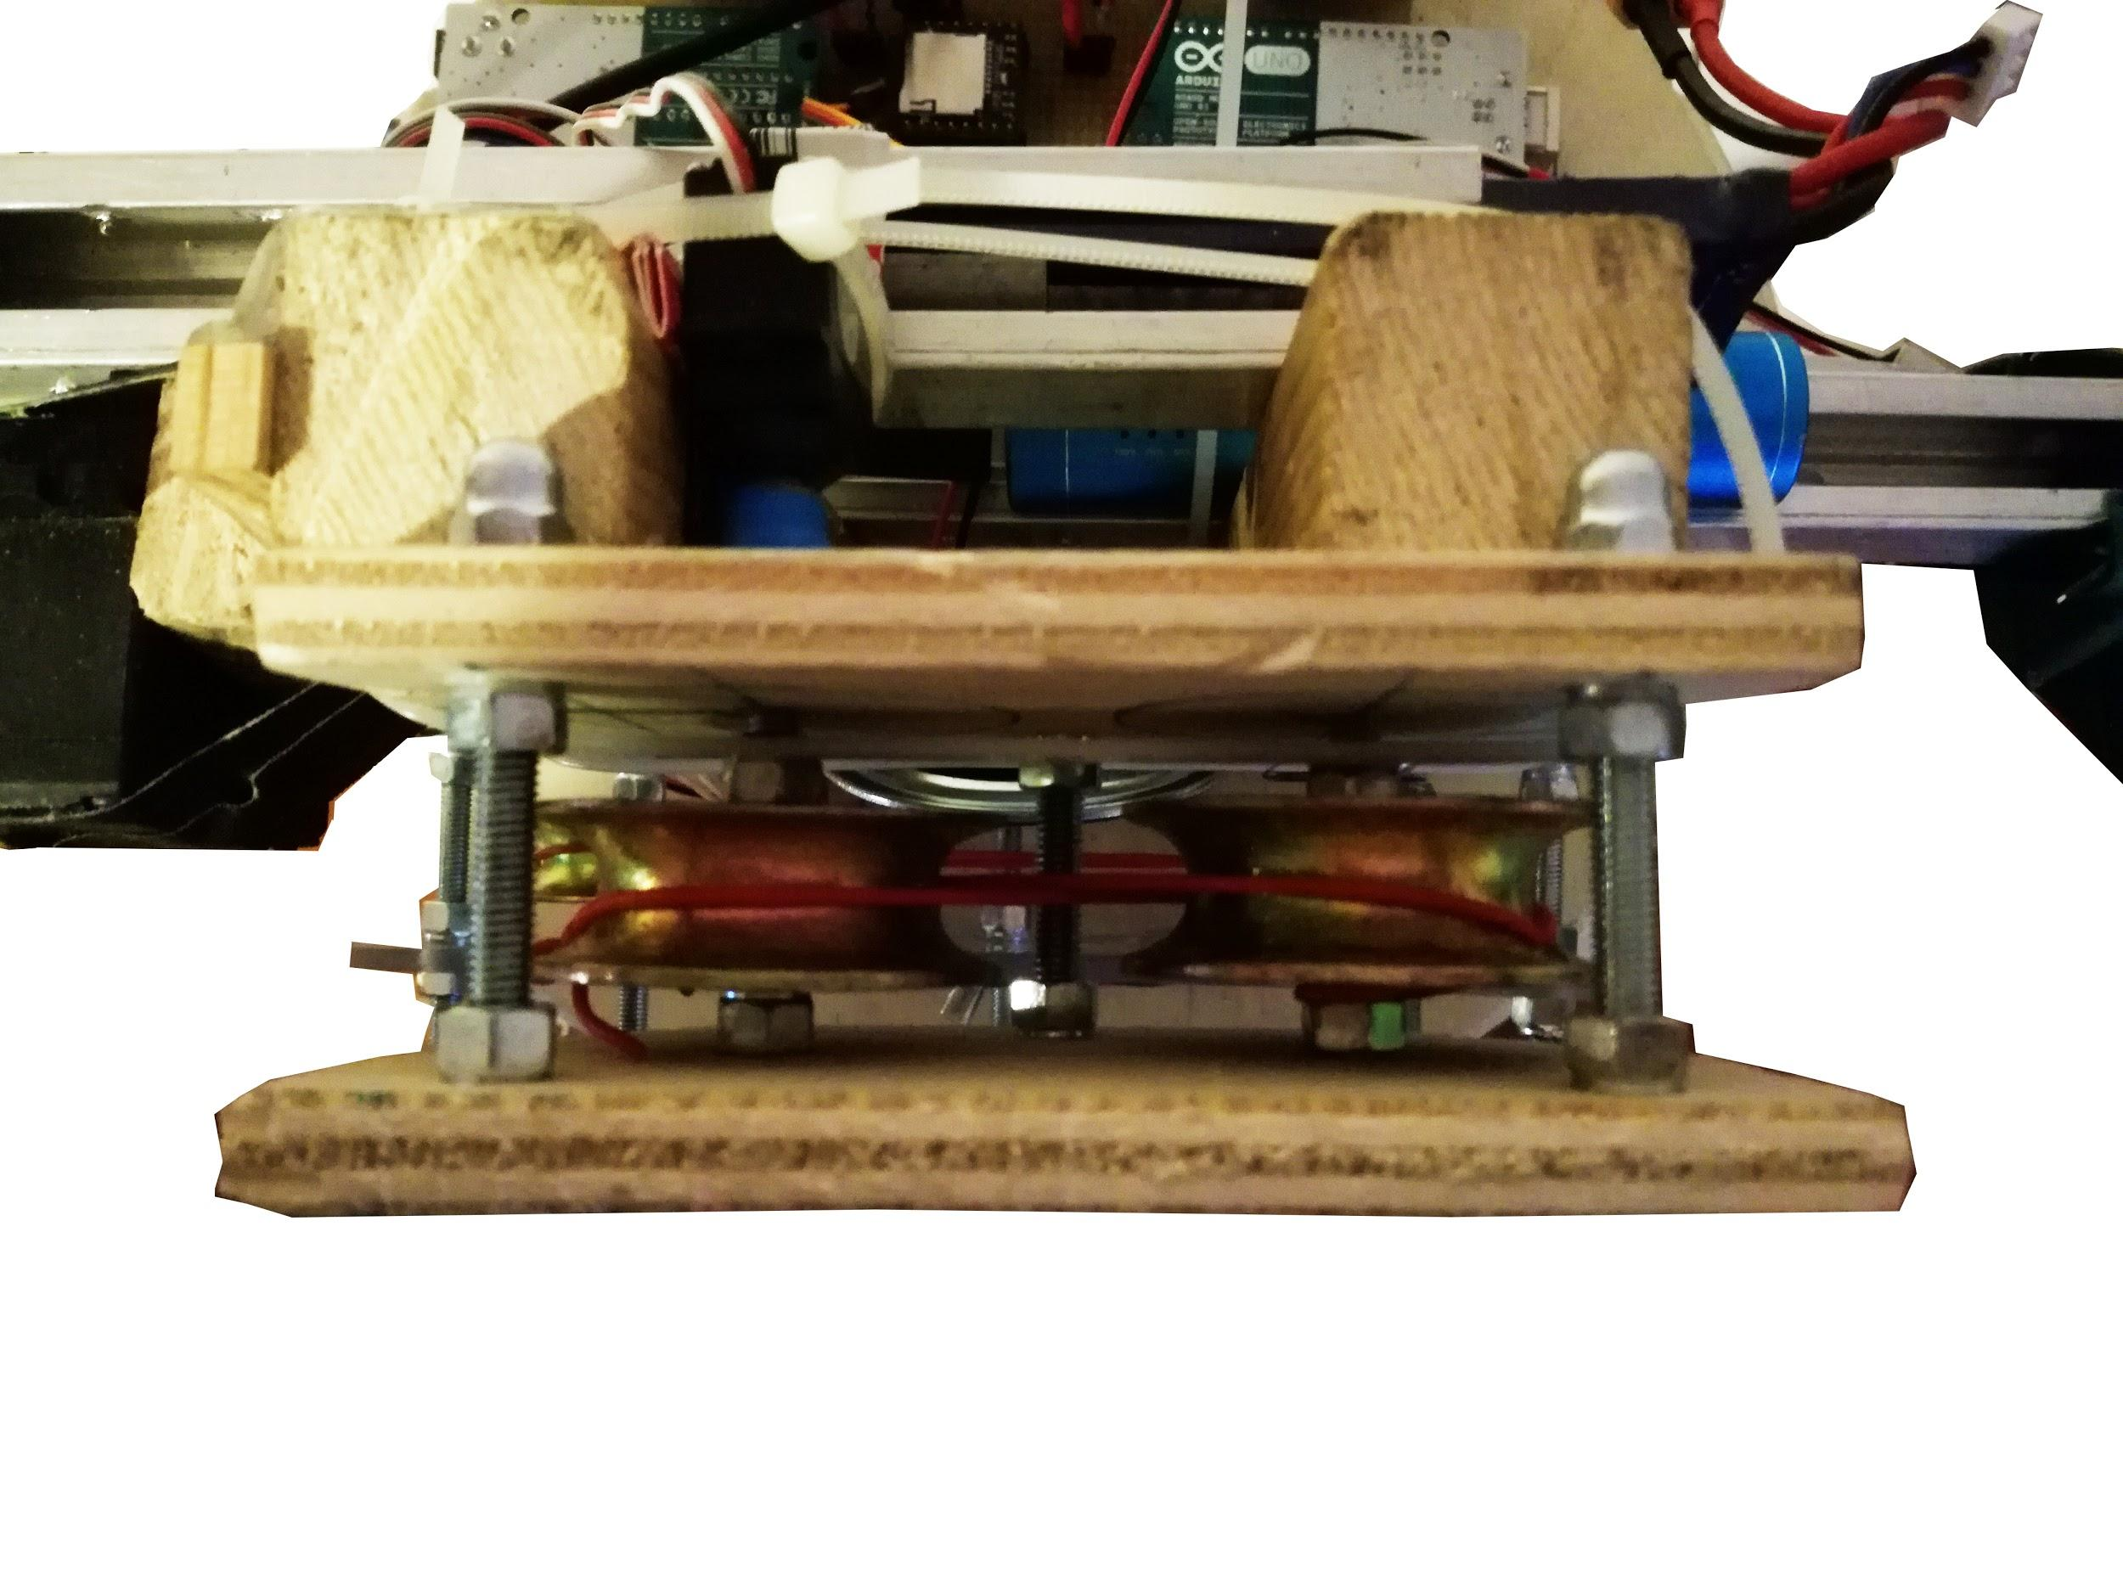

## Electronics

The primary platform is an Arduino UNO, for our project we are using 2 of them for the control of all the actions of the robot, we are using primary one (Arduino Body) for the movement of the robot for following of the people because we want to prioritize this action and to make it in parallel with the other actions that can be done with the robot, using 3 sonars HC-SR04 for the localization, and 1 servo for the rotation of the body the action can be done, we are using a servo for this, due to the mechanics implemented the weight that it has to move is not much.

The second Arduino controls the interactions with the persons, the interaction is based on the actions: Say Hi, game with nachos, change of the color of the eyes, voice messages and songs.

For the Say Hi, the Arduino slave waits for a signal for the Arduino Master to recognize that the person is in the desired range, to start saying Hi, this actions is done using a servo motor and the structure connected to it for the right hand while waits to it to happens the robot is playing the mexican song “La cucaracha” using the DF player and waves the mexican flag. Once is on the desired range the robot start saying hi still waving the hand and saying “Alto là gringo vuoi prende un Taco”

For the Game with nachos, we have a photoresistor on the left hand of the robot, with a resistors to do a divider of voltage for the analog inputs of the robot, to sense the change of the intensity of light to activate a motor that moves the hand of the robot when it detects that a hand of the customer is approaching for the nachos, the motor is a servo motor, connected to the left arm structure that allows the rotation.

For the color of the eyes, we are using 2 RGB LEDs that are connected in parallel, to activated the same actions in both of them using half of the pins, they change color depending of different states of the robot, they start blue, when the robot detects a person closer than 50cm it changes the color to green, when is doing the game with the nachos, and the arm moves away to avoid the person to pick a nacho, change the color to red, then when turning back goes to blue and then green again if the person is closer than 50cm or remains blue if the person moves further.

For the connections of all the sensors and actuators we used cables with connectors, to have easy change if a part of the robot breaks down, all the grounds and positive voltage of the robots are placed in a single board to connect all the alimentations for all the parts that need them.

For the power of the robot, we are using 2 LIPO batteries of 5 volts with the LM317 regulator to avoid problems with the entry voltage for the parts of the robot, each battery has its own safety switch and the can be switched on-off independently.

For the schematics and drawings of the circuit of the robot remit to the electronic part of the annex.

The main problem that we had was making the power and the logics of the robots work together with the same battery, due to the problems faced trying to make this work, we decided to use 2 sources of power, one for the motors and other for the logic, this solution widely used for robotics, but we thought that will not be necessary to implement it because the robot does not have very big loads for the servos.

Bill of material.

Till now we have used almost all the implements available on the lab, with some parts, that the team members already have, for the final product, we have ordered 1 servo motor, 1 DFPlayer Mini and 2 regulators LM317 for the batteries of the robot.

The final Boom for the project can be found in the annex for electronics, Captus_bom.html

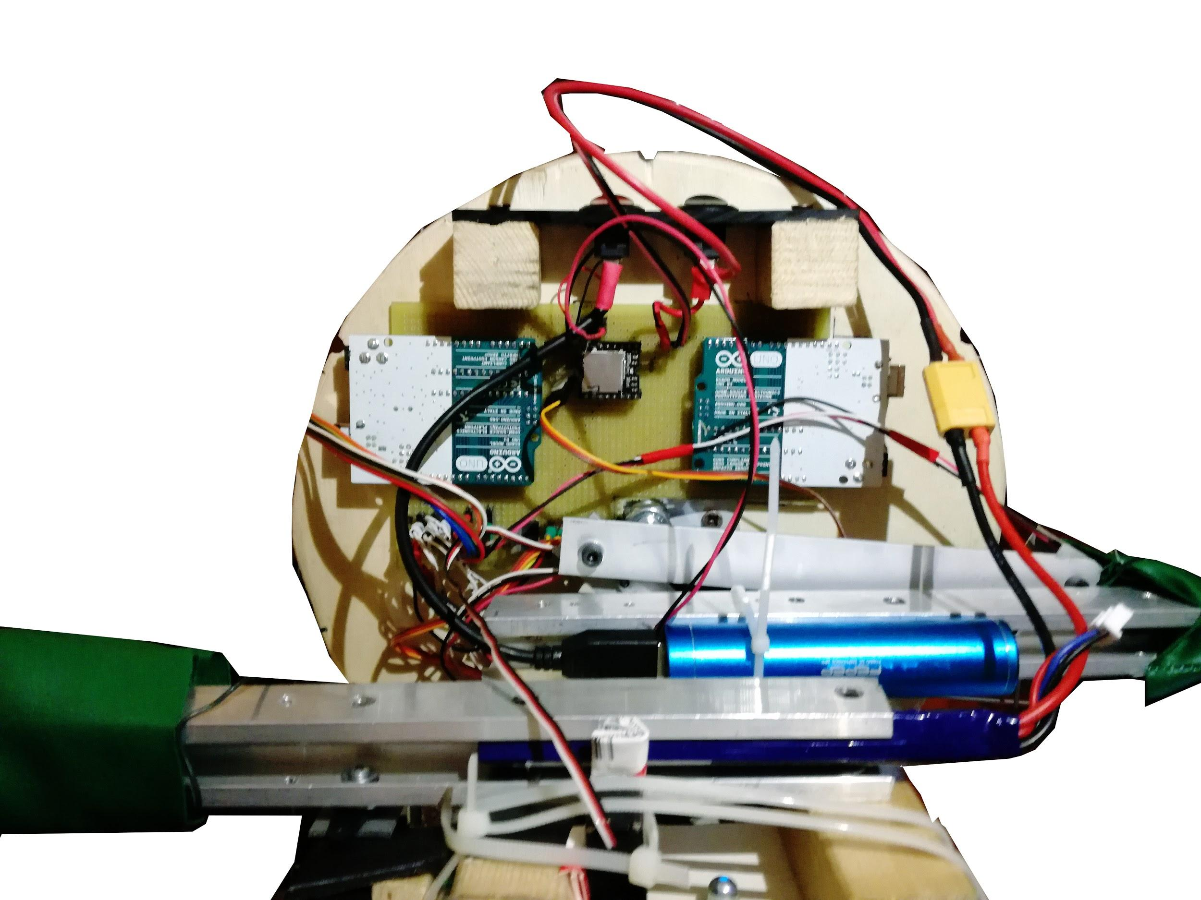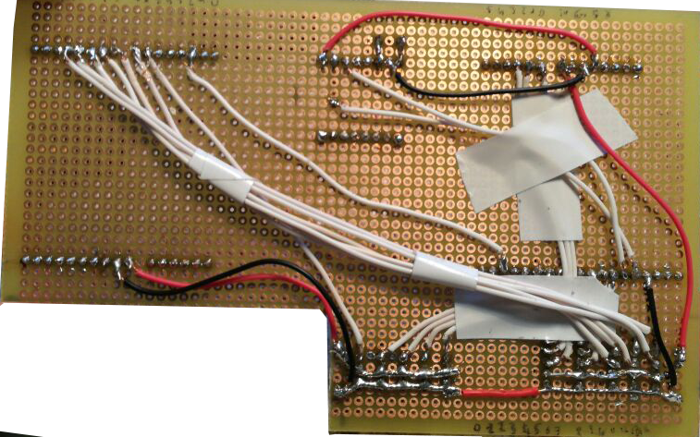

## IMG-20170406-WA0014modif.png



## 

## 

## 

## 

## Informatics

We divide the code in two Arduino, so in this way Gonzalo can follow the person always in independent way from the other actions. The two codes are called “Body” and “Secondary”.

Gonzalo Body read the sensors, move the body until the nearest person is in front of its central sonar. Finally when a person is nearer than 2 metres Arduino Body put HIGH the digital pin 2 for 0.3 seconds to advise Arduino Secondary that there is someone in front of him (and then it doesn’t send another signal for 4 seconds, in this way Gonzalo doesn’t say “Hi” continuously).

In the other side Arduino Secondary receive the signal in the digital pin 2 and says “Hi” to the person. If it receives another signal after 4 seconds it invites the person to enter in the restaurant using sentence like “entra a provare i nostri burritos” or “Fidati di Gonzalo, mangia messicano”.

Meanwhile Arduino check the photoresistor and if someone try to take Tacos it moves fast the arm to avoid the person’s hand. To do this Arduino reads the value of photoresistor every 0.2 seconds and if the new value is very different of old value the arm is moved. When the photoresistor is activated it can’t activated for the next 10 seconds for not annoying too much the person.

Finally when Gonzalo doesn’t do anything for 10 seconds, because nobody interact with it, it plays Cucaracha and move the arm with the flag.

A little explanation for the eyes.   
The led are blue for default and became red when photoresistor is activated and became green when Gonzalo say “Hi”.

# Conclusion

What we learn from this experience?

# Bibliography

# 

# 

# Annex

## Interaction

Flowchart.pdf

## Bill of Materials

Bill of materials.xls

## Electronics

Captus.pdf

Captus_schem.pdf

Captus_bom.html

## Informatics

<https://github.com/FAngelo94/Robot-Gonzalo>

## 